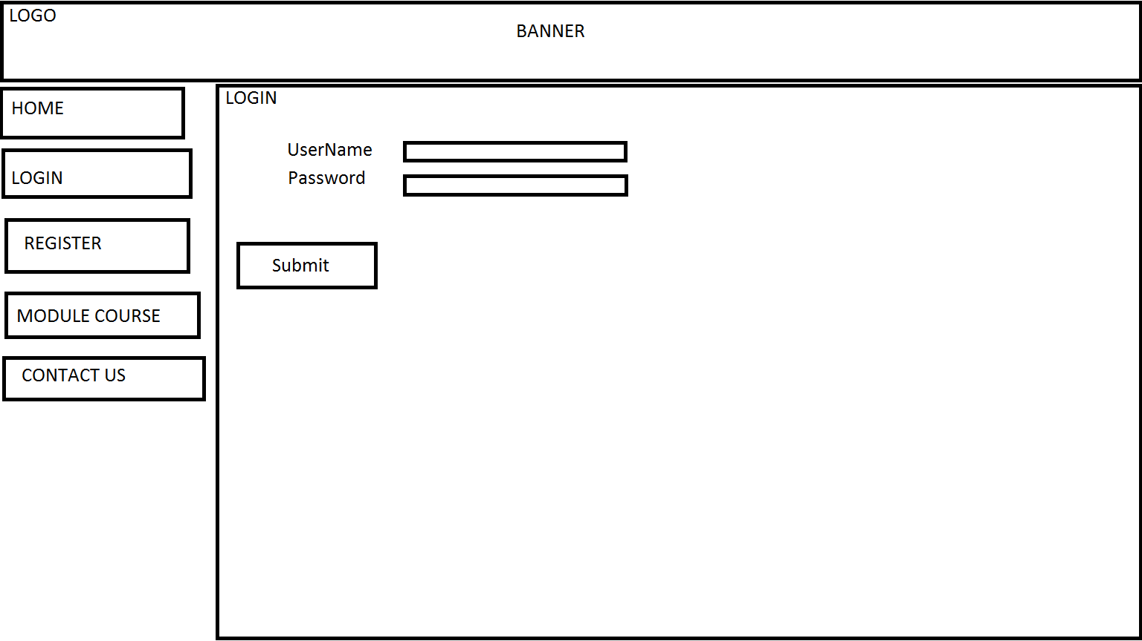

LOGO

BANNER

UserName D- l Password Ll

MODULE COURSE ΟΟΝΤΑΟΤ US